

Celebrating the artistic and cultural heritage of the labor movement and working people

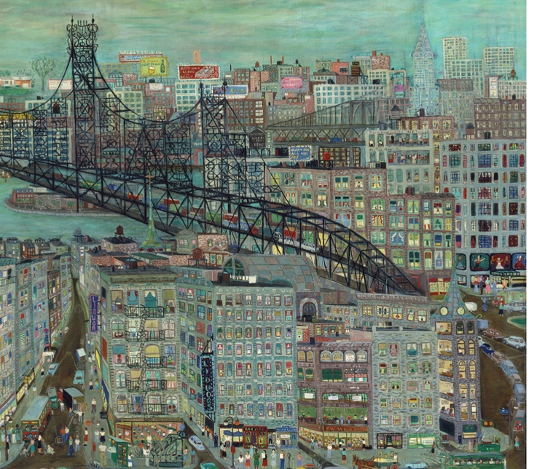
Ralph Fasanella: Lest We Forget

Visit the exhibit – Extraordinary paintings by socially engaged artist Ralph Fasanella (1914 – 1997) at the American Folk Art Museum, Columbus and 66th Street through November 30
ADMISSION IS FREE

Join us November 5 for Art and Work – Screening and Panel Discussion “Fasanella,” a 22 minute documentary, followed by a discussion with Ron Carver, Esther Cohen, Gary Schoichet and others who knew Ralph or are involved in current activist art endeavors.

Wednesday November 5, 6-8pm
Brooklyn College Graduate Center for Worker Education
25 Broadway 7th Floor ( in Lower Manhattan)
RSVP to info@laborarts.org

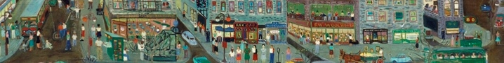
Contact Rachel Bernstein / Esther Cohen / Evelyn Jones Rich at info@LaborArts.org or 212 966-4014 x1703

