**You’re Invited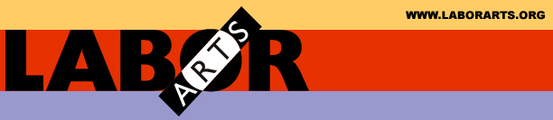 to Celebrate the Winners**

***Making Work Visible* Contest**

**Poetry – Art – Fiction – Non-Fiction**

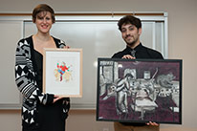

**Wednesday April 22, 2015**

**6:00 pm - 7:30 pm**

Join Donald Rubin, Brooklyn College Dean Rich Greenwald and the contest coordinators to congratulate the winners of this year’s CUNY/LaborArts contest

– you’ll be inspired.

Brooklyn College Graduate Center for Worker Education

7th Floor 25 Broadway, Manhattan

Refreshments will be served

**RSVP info@LaborArts.org www.LaborArts.org**

