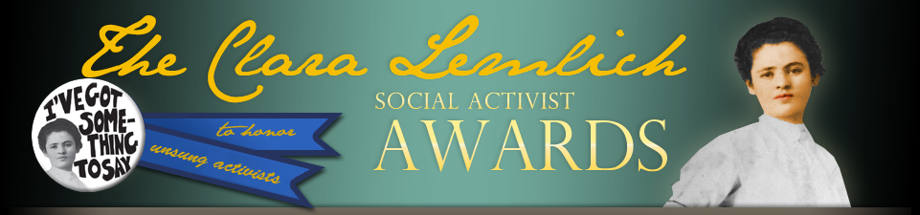

Join LaborArts and the Triangle Fire Coalition

Monday May 4, 2015
6:30 – 8:30 pm

Fifth Annual

Clara Lemlich Awards

Honoring unsung activists, women who have been working for the larger good all their lives, in the tradition of those who sparked so many reforms in the aftermath of the Triangle Shirtwaist Factory Fire.

Puffin Gallery for Social Activism
Museum of the City of New York
1220 Fifth Avenue at 103rd Street

Refreshments Music
RSVP to info@laborarts.org

Visit laborarts.org/lemlichawards to see 2011 -2014 honorees
Visit rememberthetrianglefire.org for information about Clara Lemlich and the Triangle Fire
Contacts - Rachel Bernstein 212 966-4014/Esther Cohen bookdoctor@rcn.com/Evelyn Jones Rich 212 367-8883

