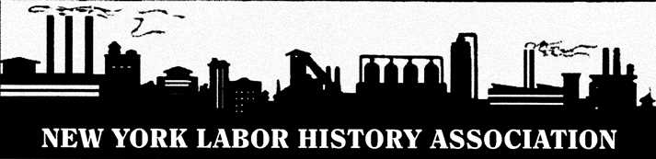

**A bridge between past and present**

**NYLHA Membership Form**

PLEASE TYPE OR PRINT CLEARLY

Name: _____________________________________ Institutional Affiliation: ___________________________

Mailing Address: ____________________________________________________________________________

City: ______________________ State: _____________ Zip Code: _____________ Phone_________________

E-Mail: ___________________________________

Most of our announcements go out via e-mail.

ABOUT NYLHA

Founded in 1976 by trade unionists, academics, students, archivists, educators, labor editors, attorneys, and retirees, mostly from New York State, NYLHA encourages the study of workers and their organizations, past and present.

It serves as a bridge between the past and the present, between trade unionists and academics.

Our members include a wide range of individuals and unions interested in transforming the future by retrieving workers’ history and relating it to present problems and challenges facing workers.

*JOIN US!*

New Member? Yes □

ABOUT NYLHA

**Founded in 1976 by trade unionists,**

ANNUAL DUES

□ Member / $20

□ Contributing Member / $50

Send completed form with a check for dues plus any

additional tax-deductible donation you would like to

make (payable to the New York Labor History Association)

to the address below. You can also join online at

newyorklaborhistory.org

Peter Filardo, Treasurer

340 W. 28th Street, #18A

New York, NY 10001-4765

Thank you for your support!